Project Development Phase
Model Performance Test

Team ID | SWTID-2026-7816
Project Name | Auto Ticket Classification using Flow Designer

Model Performance Testing:
Project team shall fill the following information in model performance testing template.
S.No. | Parameter | Values | Screenshot
1. | Model Summary | ServiceNow Flow Designer automation for automatic IT ticket classification. The flow analyzes the Short Description and assigns Category and Subcategory. Supported cases: Wi-Fi/Network, Projector/Hardware, Password/Access, and Slow Computer/Performance. | 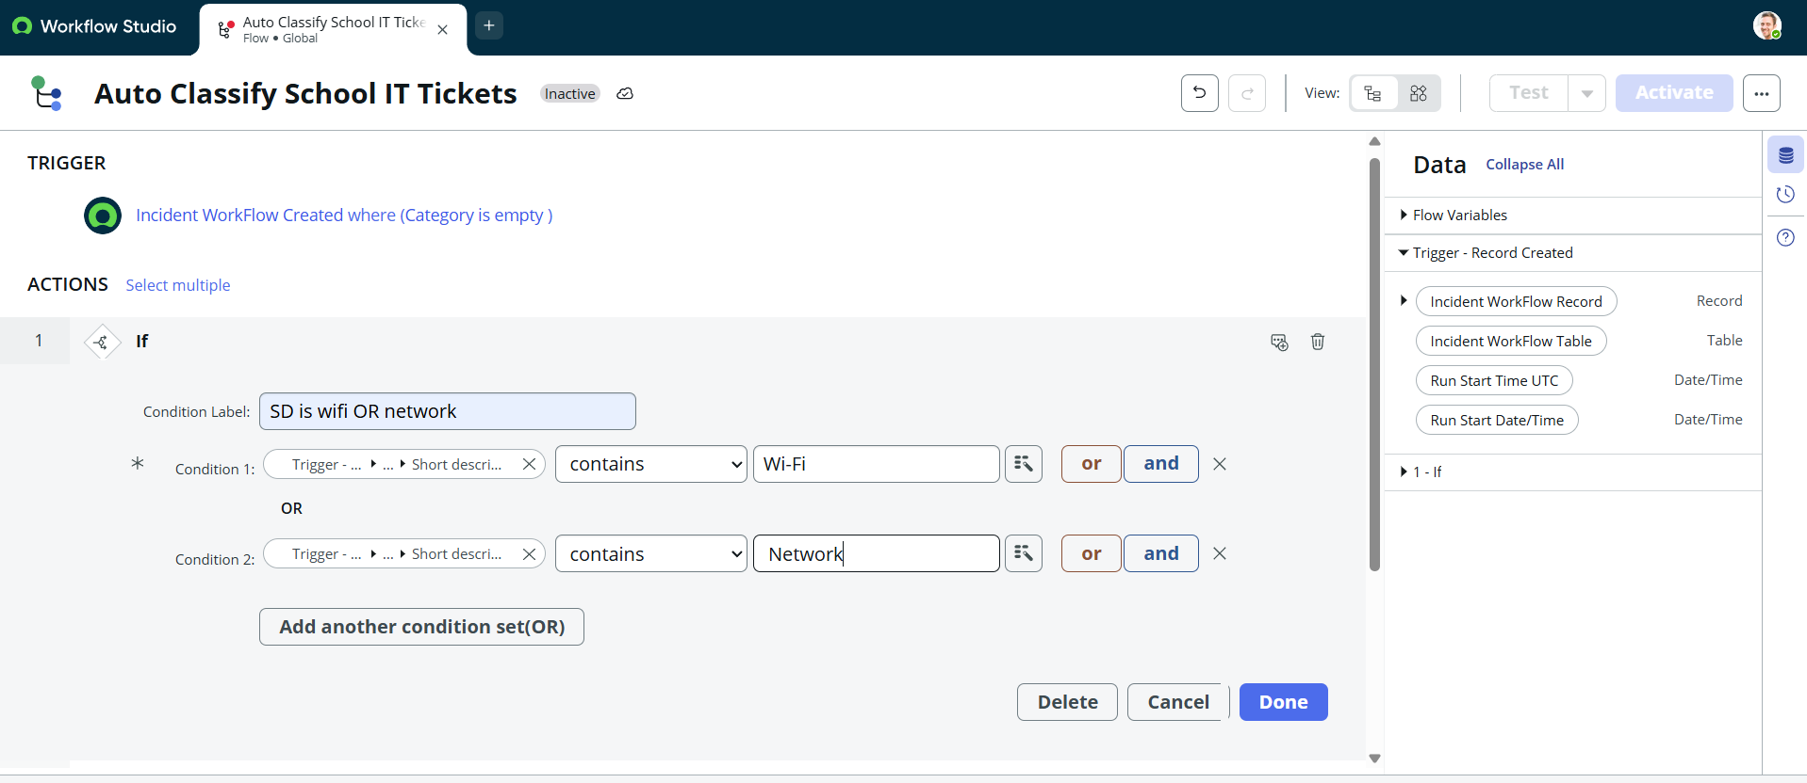
2. | Accuracy | Not applicable – this is a no-code automation project, not an ML model.  Functional Testing: Passed for the documented Wi-Fi and Projector test scenarios.  Wi-Fi → Network / Wi-Fi  Projector → Hardware / Projector | 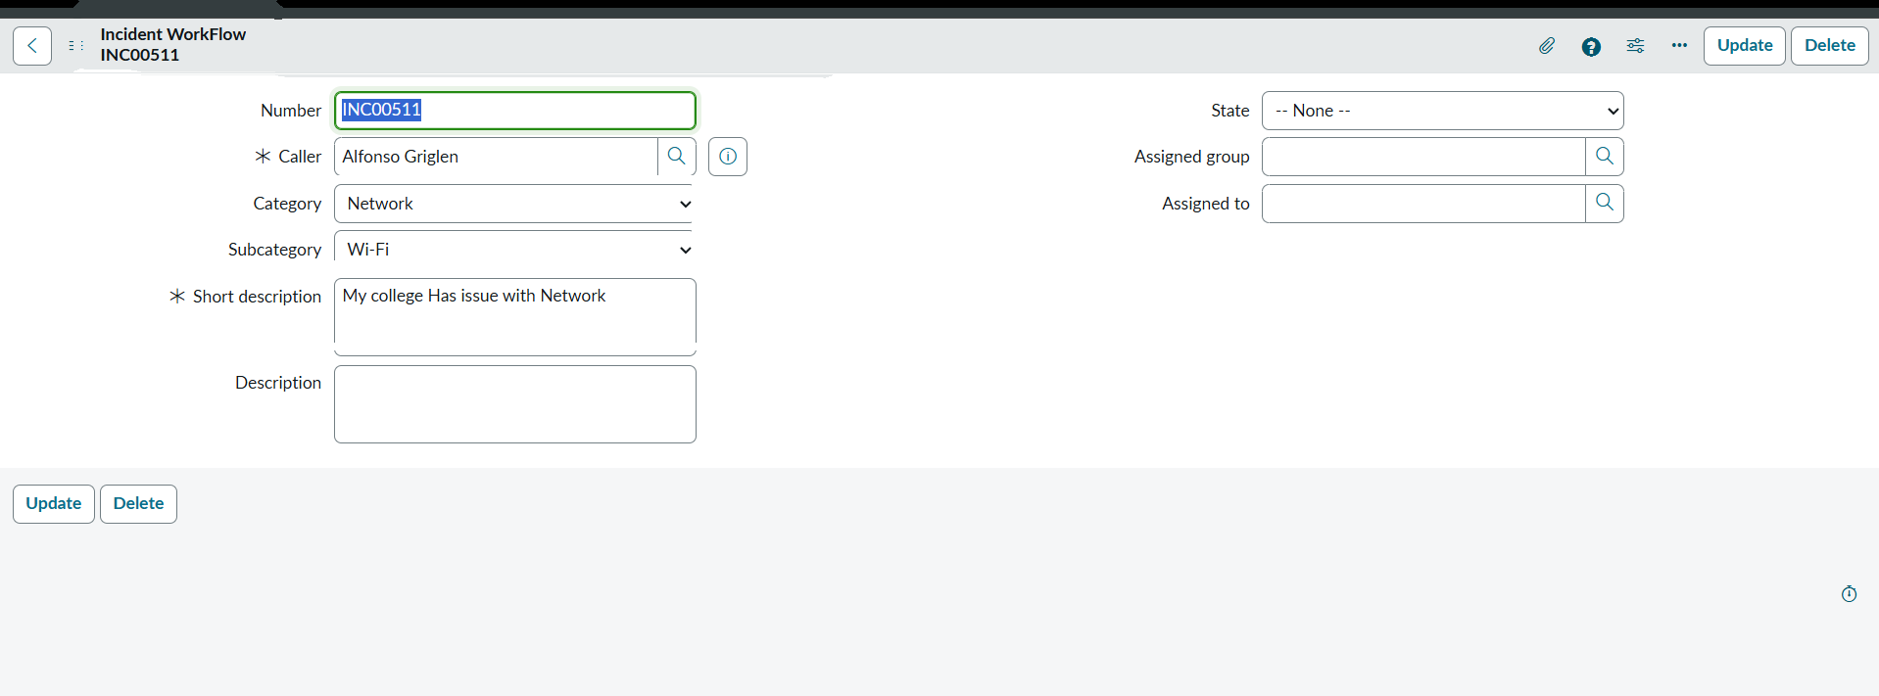
3. | Confidence Score (Only Yolo Projects) | Not Applicable (N/A)  The project uses ServiceNow Flow Designer keyword-based rules and does not use YOLO or a machine-learning confidence score. | 